Year 9 |  | Pythagoras Theorem | Calculator Allowed
Skills and Knowledge Assessed:  - Investigate Pythagoras’ Theorem and its application to solving simple problems involving right angled triangles (ACMMG222)  - Investigate the concept of irrational numbers, including π (ACMMG186) |  |  | Name_________________
Section 1 Short Answer Section
Write all working and answers in the spaces provided on this test paper.
Diagrams are not drawn to scale unless otherwise stated.

State Pythagoras Theorem for the triangle shown below.
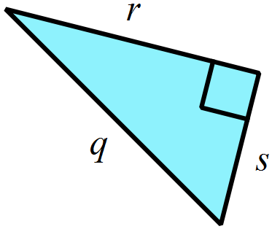

……………………………………………….

Find the value of x.

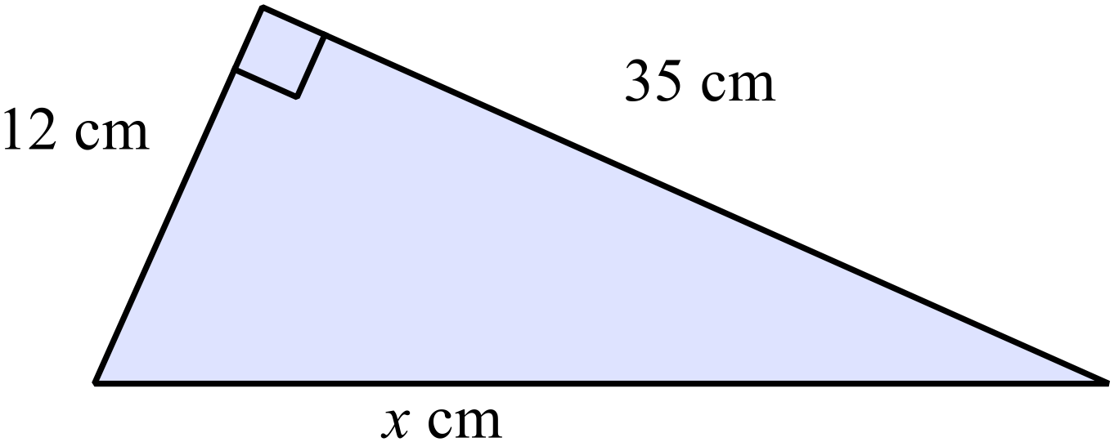
………………………………………………

………………………………………………

……………………………………………....

………………………………………………

Find the value of w.
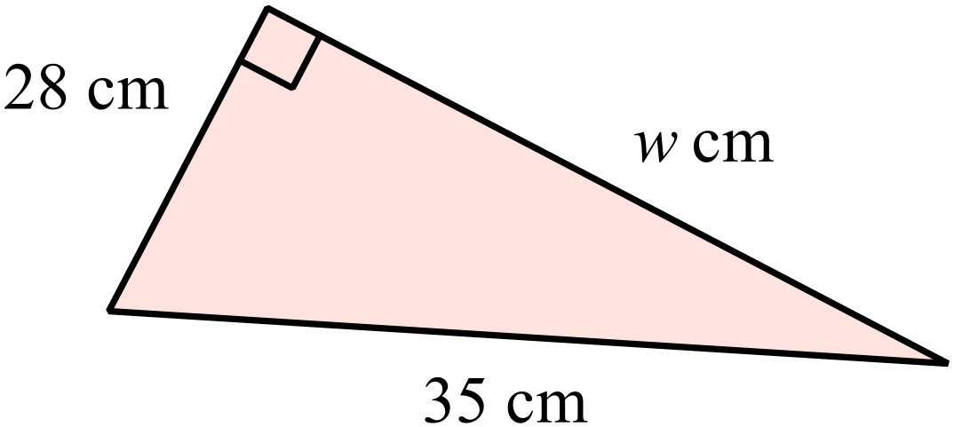
………………………………………

………………………………………

………………………………………

……………………………………
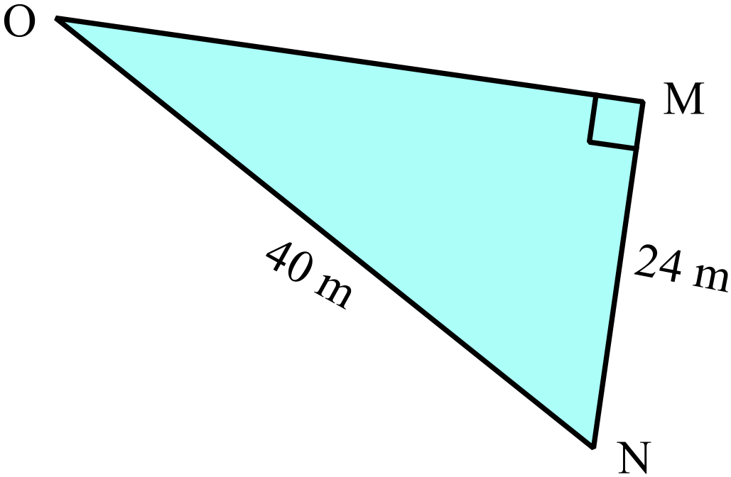What is the length of OM ?

………………………………………

………………………………………

………………………………………

………………………………………
Find the distance XZ to the nearest centimetre.
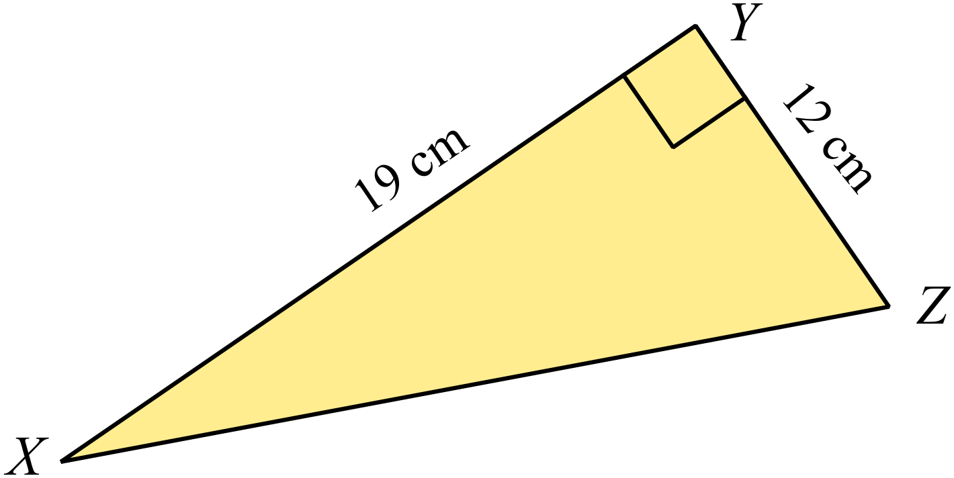

………………………………………

………………………………………

………………………………………

………………………………………
Is a triangle with the dimensions below, right angled? Explain why?
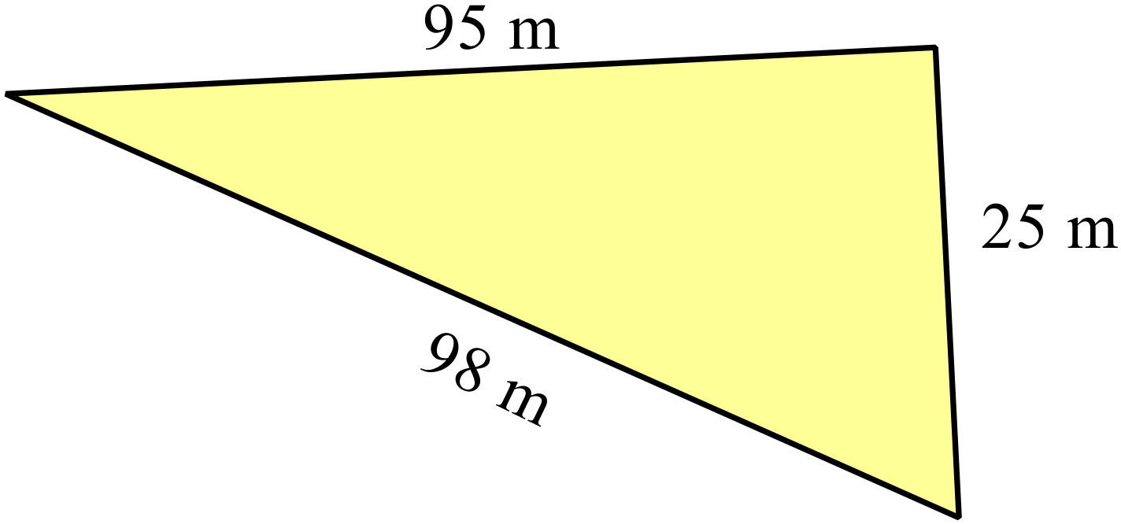

…………………………………………………………………………………………….

…………………………………………………………………………………………….

…………………………………………………………………………………………….
Find the length of KL (leave your answer as a surd).
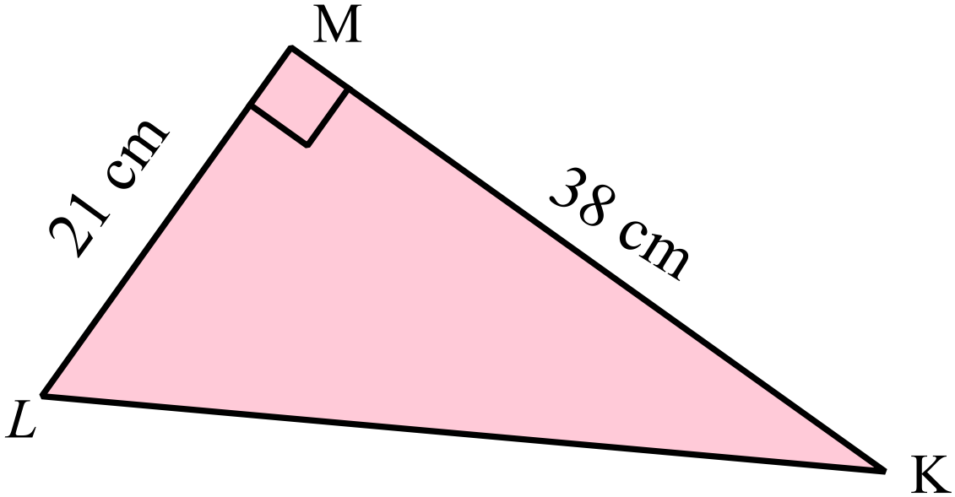
………………………………………

………………………………………

………………………………………

………………………………………
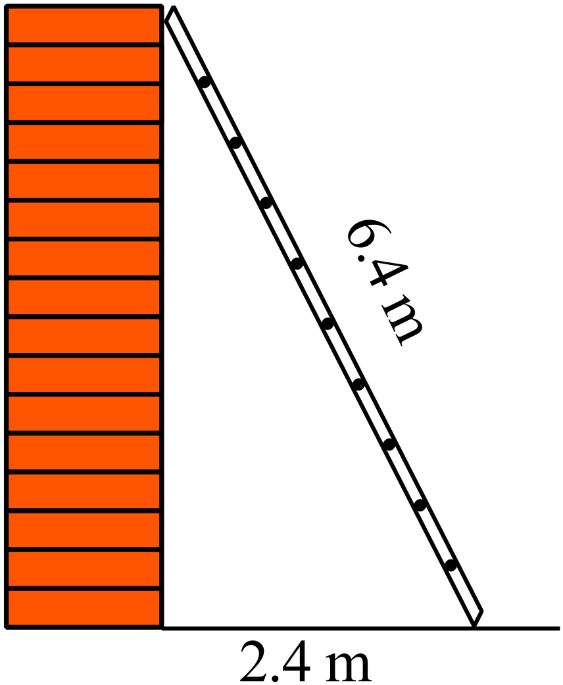The ladder shown, leans against the top of the wall.
What is the height of the wall, correct to the nearest 10th of a metre?

………………………………………

………………………………………

………………………………………

………………………………………
Are either of the following two sets of numbers, a Pythagorean triad (show your reasons)?
Set A (48, 64, 80) Set B (50, 90, 105)

…………………………………………………………………………………………….

…………………………………………………………………………………………….

…………………………………………………………………………………………….
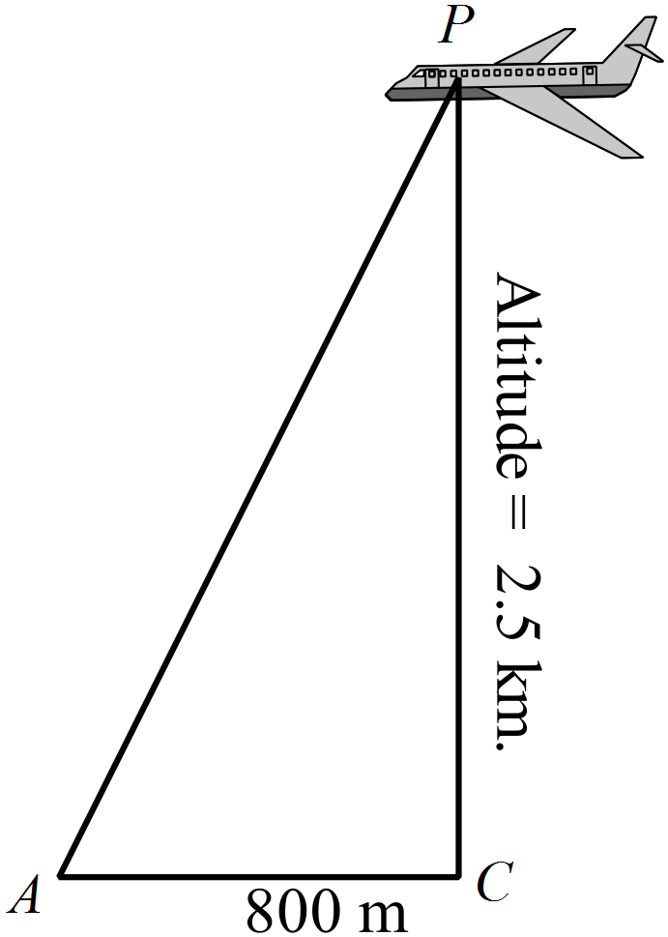A plane P is known to be at an altitude of 2.5 km above point C.
It is viewed from point A, which is 800 m horizontally from C.
What is the distance AP?

………………………………………

………………………………………

………………………………………

………………………………………
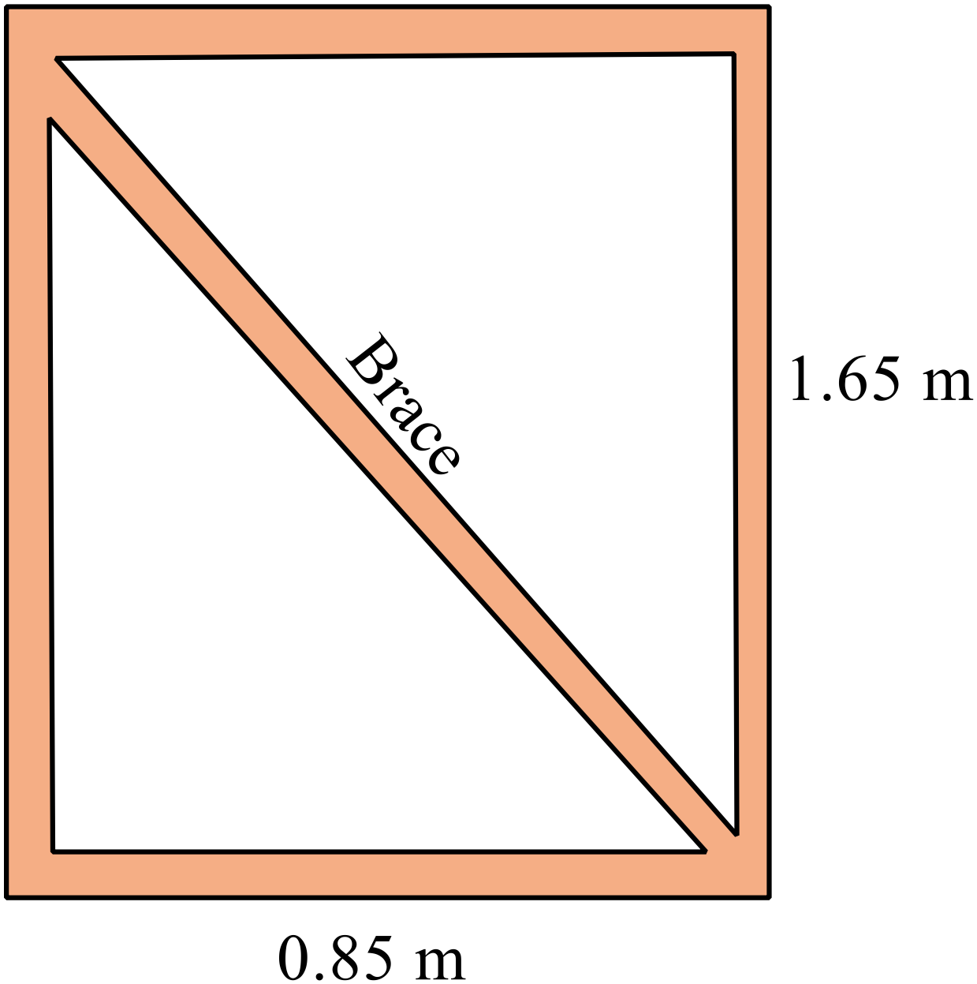Gerald is building a gate to go in his fence.
He needs a diagonal brace to support the frame of the gate.
What is the length of the brace, correct to the nearest centimetre?

…………………………………………….

……………………………………………

……………………………………………

……………………………………………
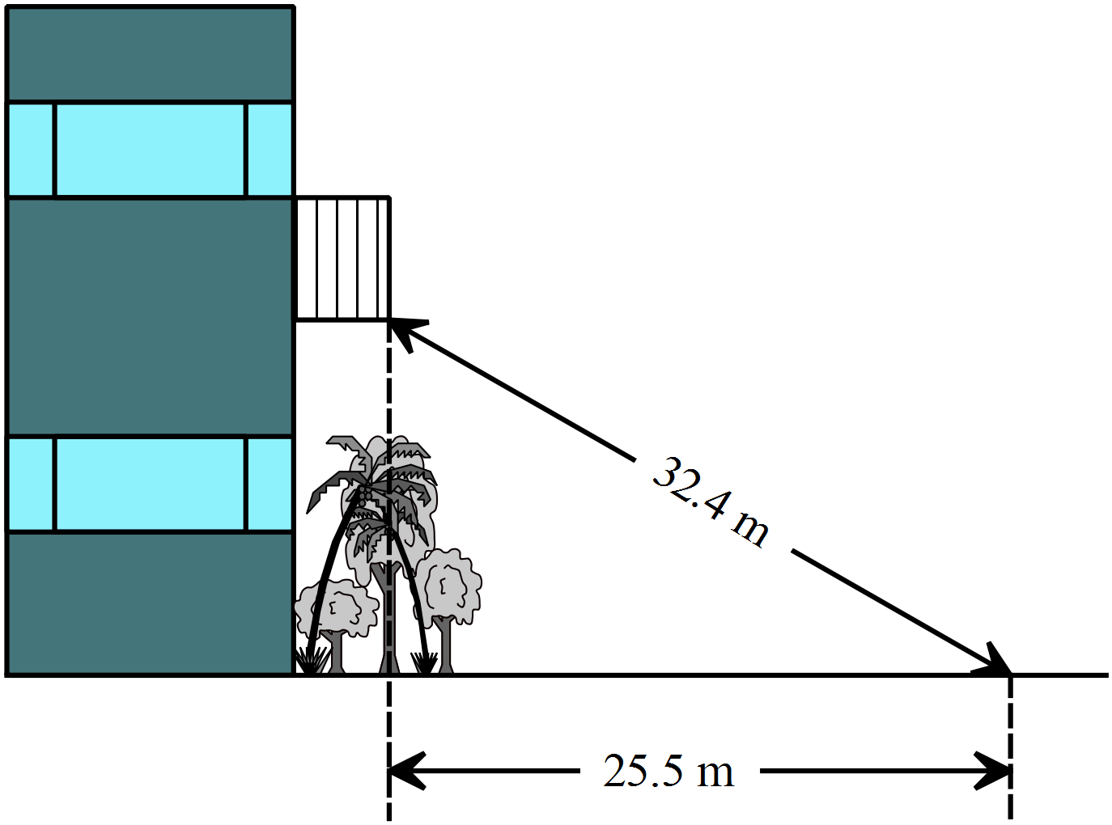The height of the balcony could not be measured directly because of garden beds, so the measurements shown were taken.

Calculate the height of the balcony, to the nearest metre.

…………………………………….

…………………………………….

……………………………………

……………………………………

……………………………………
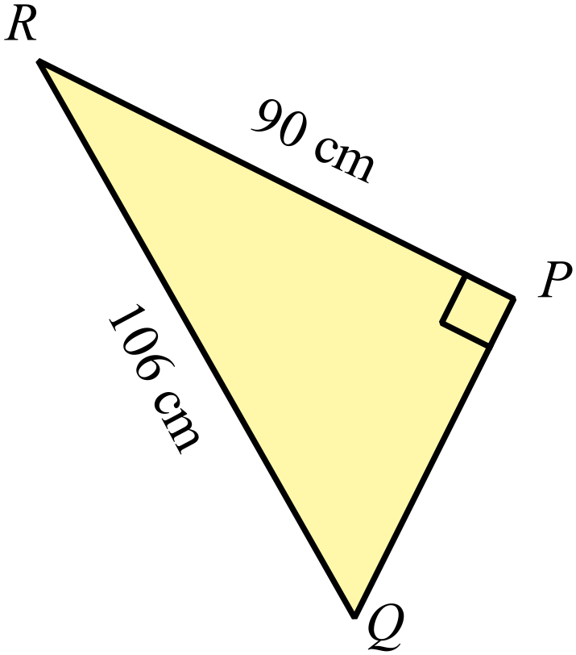What is the perimeter of the triangle PQR?

…………………………………………….

……………………………………………

……………………………………………

……………………………………………
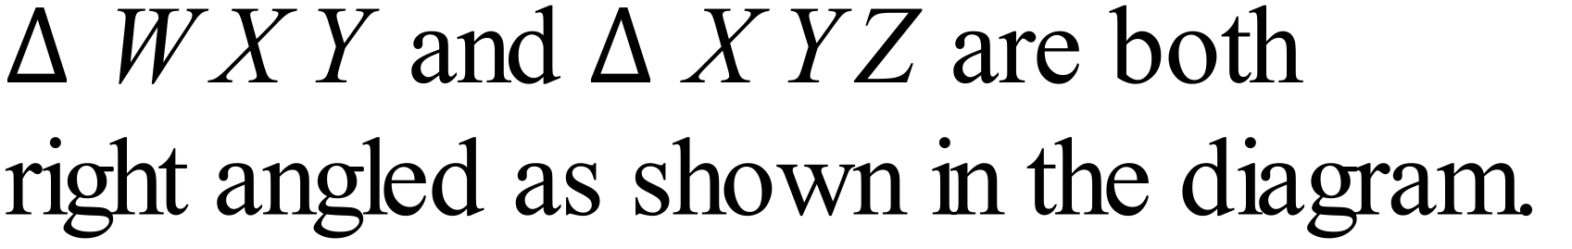
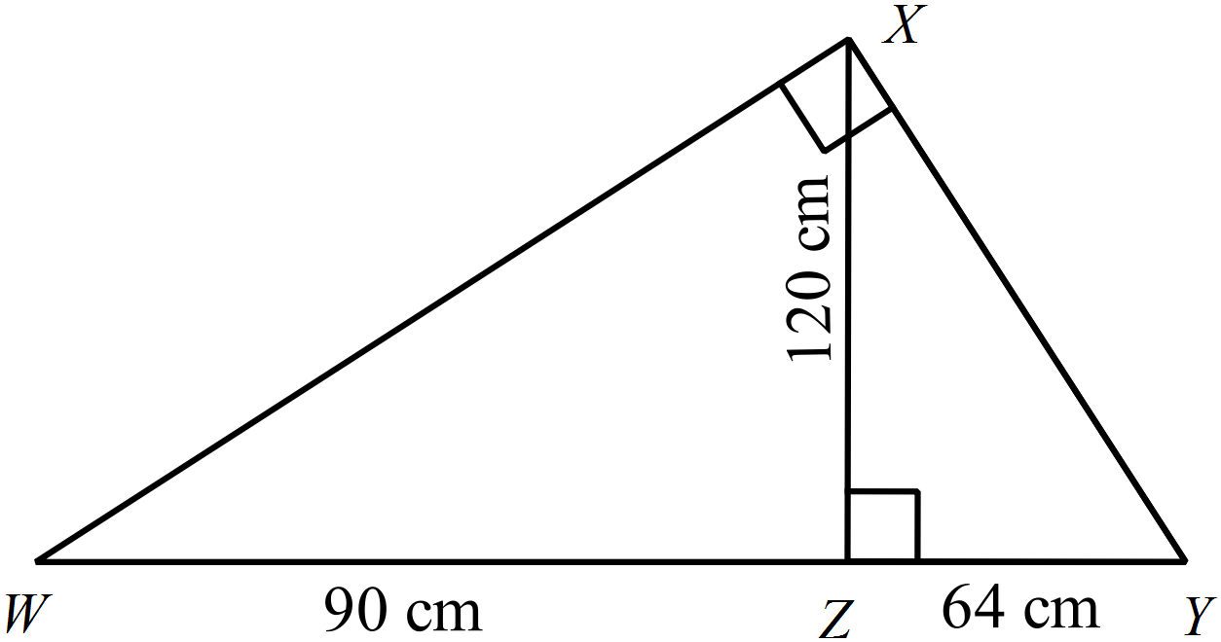Also XZ = 120 cm, WZ = 90 cm and YZ = 64 cm.
Find the perimeter of triangle WXY.

…………………………………………….

……………………………………………

……………………………………………

……………………………………………

AC = 77 m, AB = 51 m and BD = 24 m.
Calculate the distance BC.
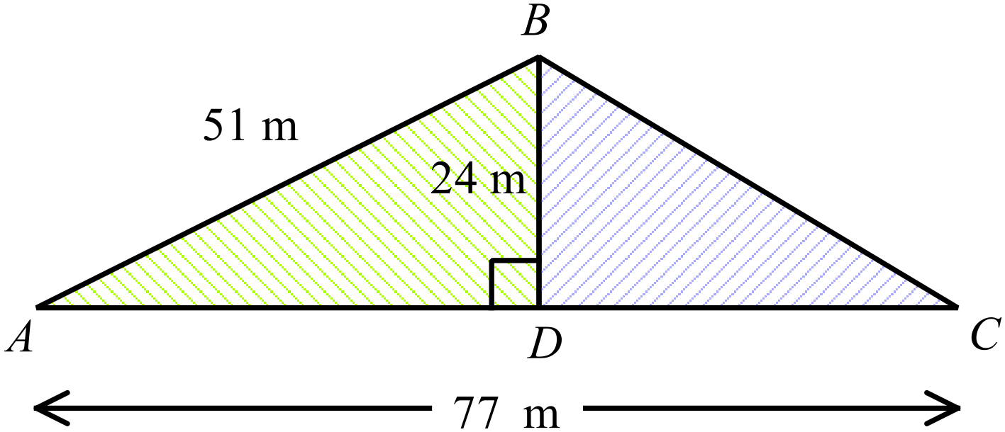
…………………………………………….

……………………………………………

……………………………………………

……………………………………………

Year 9 |  | Pythagoras Theorem | Calculator Allowed
 |  | Pythagoras Theorem | Name_________________
Section 2 Multiple Choice Section
Mark all your answers on the accompanying multiple choice answer sheet, not on this test paper. You may do any working out on this test paper. Calculators are allowed for this section.

Which side is the hypotenuse of the right triangle STU?
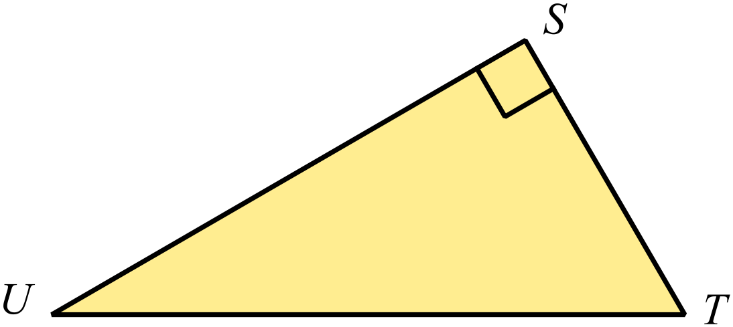
A. ST
B. SU
C. TU
D. US
Which is a correct statement of Pythagoras Theorem for the triangle shown below.
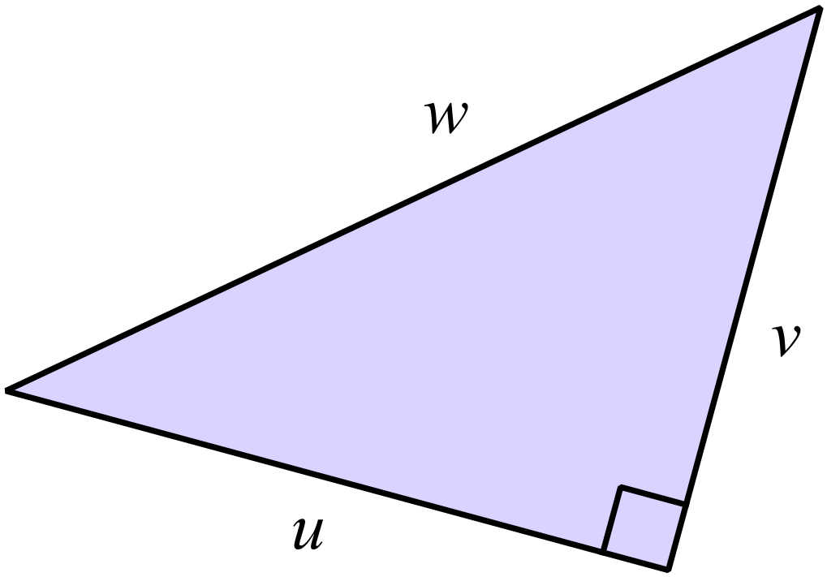
A. 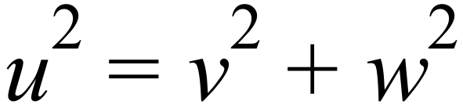
B. 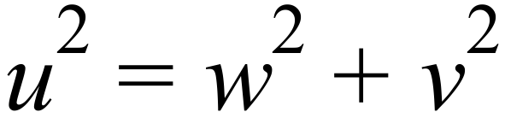
C. 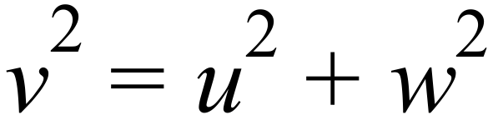
D. 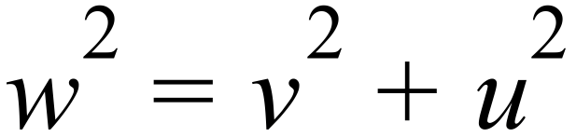

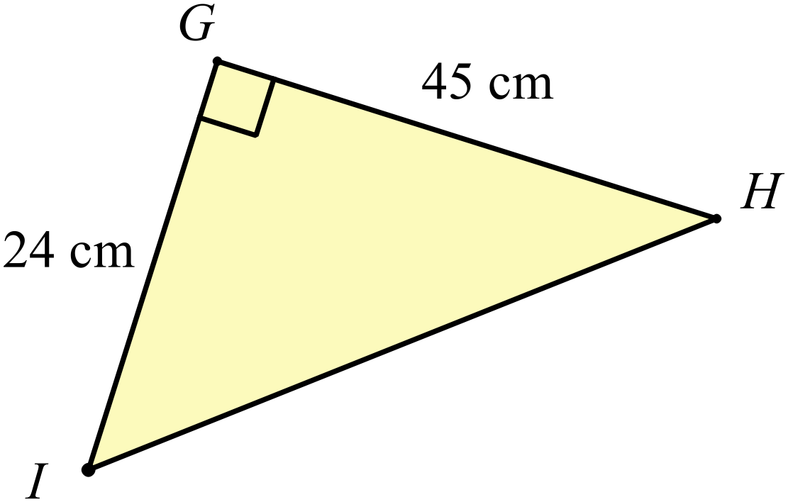Find the length of HI

A. 21
B. 38
C. 51
D. 69

Find the value of b in the triangle below.
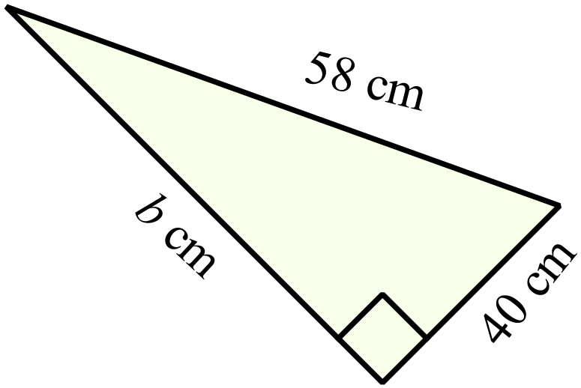
A. 18 cm
B. 42 cm
C. 84 cm
D. 98 cm

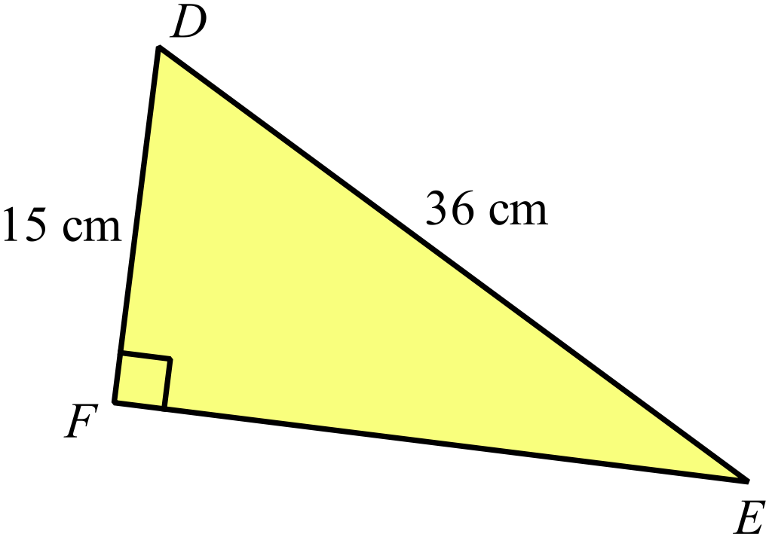Calculate the length of EF, correct to one decimal place.

A. 21.0 cm
B. 32.7 cm
C. 39.0 cm
D. 51.0 cm

Which of the following is a Pythagorean triad?

A. {21, 22, 29} B. {21, 48, 52} C. {21, 99, 101} D. {21, 28, 35}

Which of the triangles below are right angled?
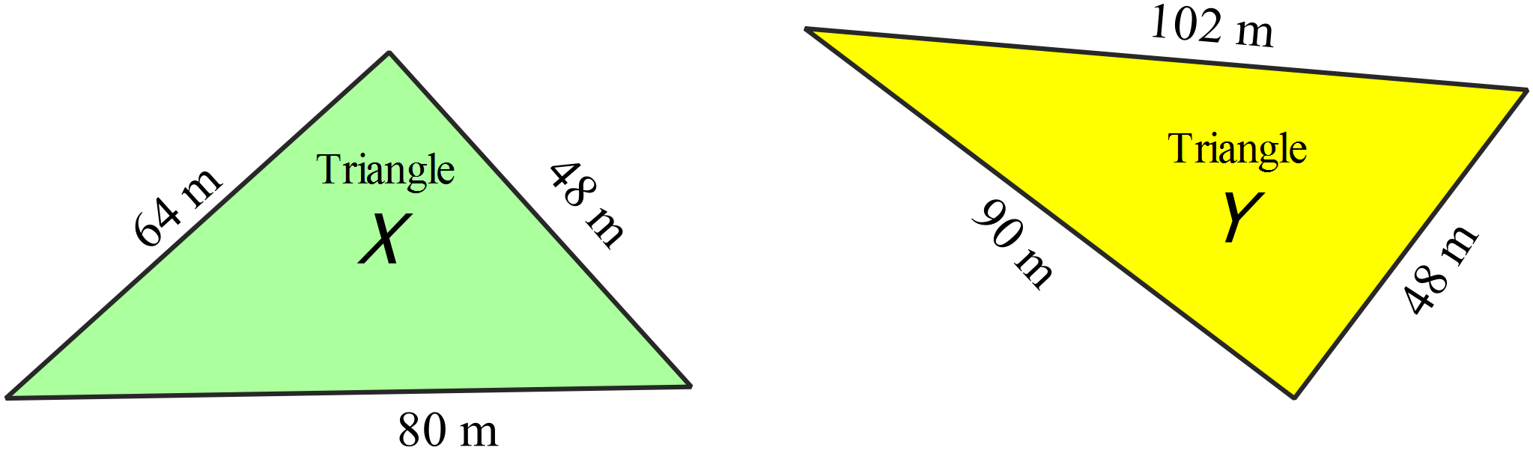

A. Both triangles are right angled.
B. Neither triangle is right angled.
C. Only triangle X is right angled.
D. Only triangle Y is right angled.
A rectangular LED/LCD television screen measures 98 cm by 126 cm.
The size is described by the length of the diagonal of the television.
How would it be described?

A. A 160 cm LED/LCD television.
B. A 204 cm LED/LCD television.
C. A 224 cm LED/LCD television.
D. A 240 cm LED/LCD television.
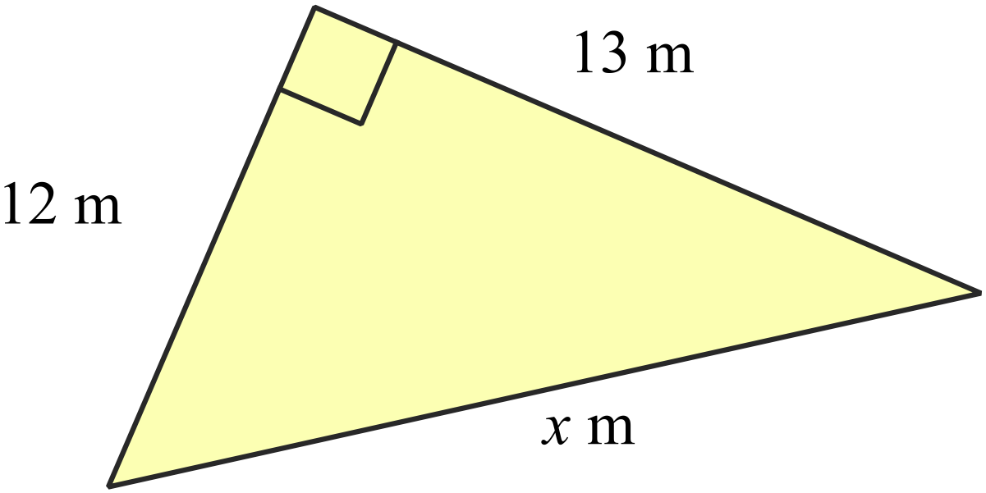What is the value of x in the triangle shown?

A. 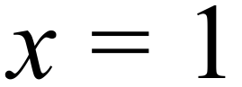
B. 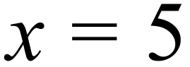
C. 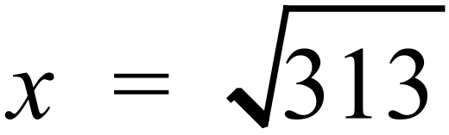
D. 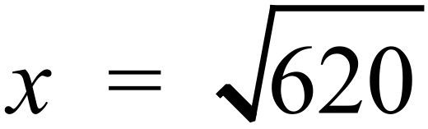

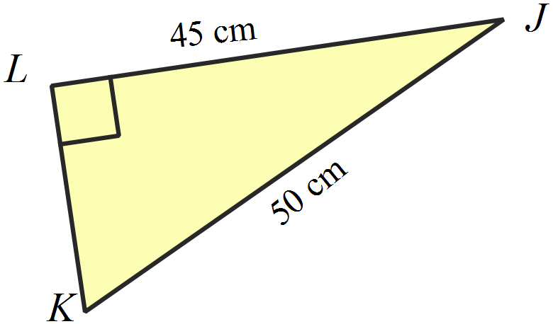What is the length of KL in the triangle shown?

A. 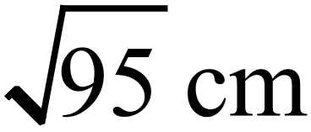
B. 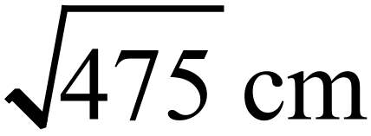
C. 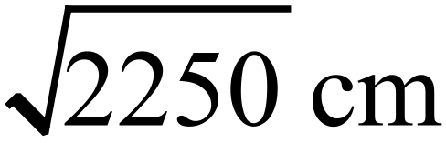
D. 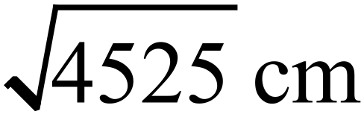

What is the perimeter of the triangle DEF?
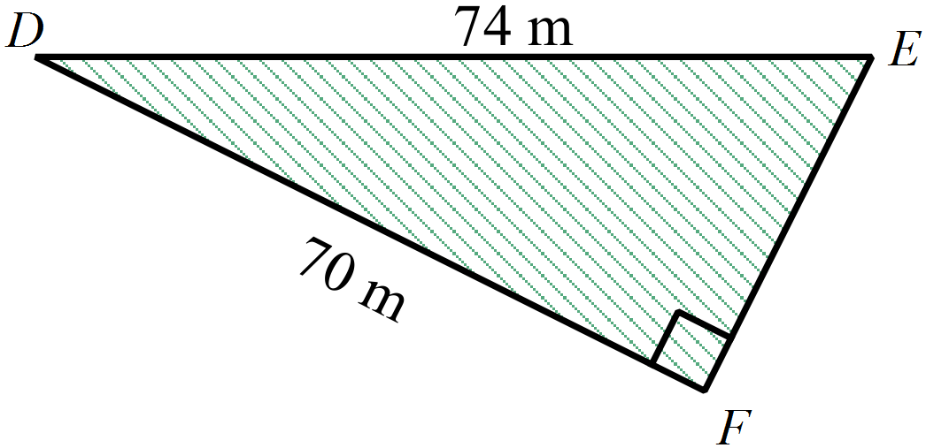
A. 120 m
B. 144 m
C. 168 m
D. 188 m

What is the area of the triangle PQR?
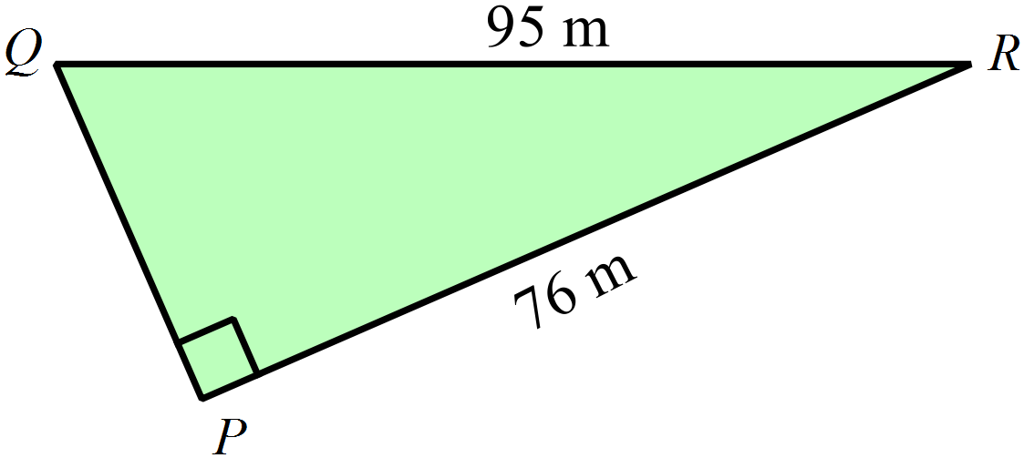
A. 171 m²
B. 228 m²
C. 2 166 m²
D. 3 610 m²

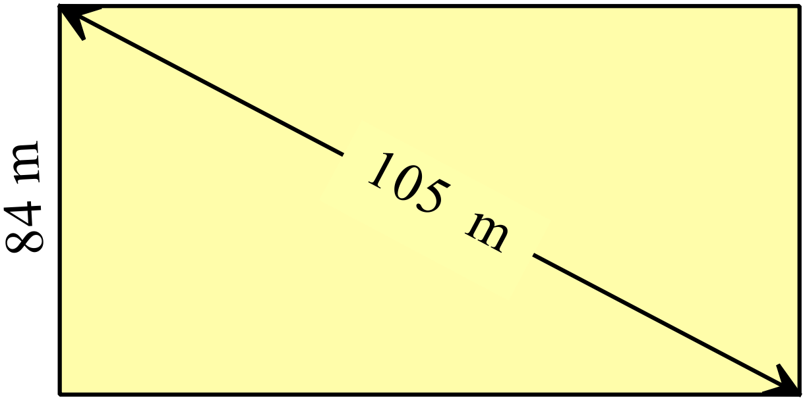What is the area of the rectangle shown?

A. 5 292 m²
B. 7 056 m²
C. 8 820 m²
D. 11 025 m²
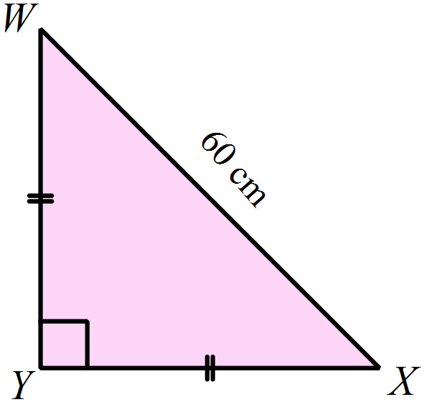In 
What is the perimeter of the triangle?

A. 120 cm
B. 145 cm
C. 165 cm
D. 180 cm

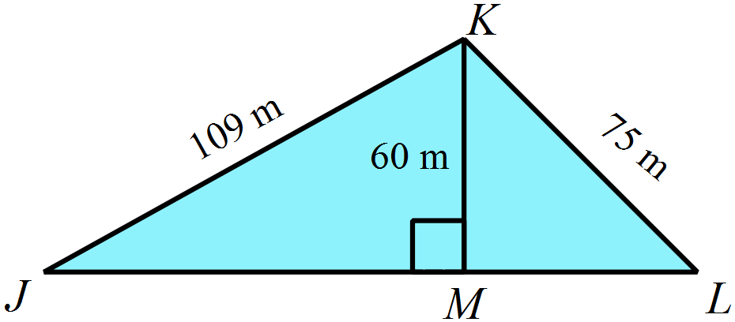What is the length of JL in the triangle shown?

A. 45 m
B. 91 m
C. 124 m
D. 136 m

Multiple Choice Answer Sheet
Pythagoras Theorem
Name _____________________________________________
Completely fill the response oval representing the most correct answer.

1. A B C D
2. A B C D
3. A B C D
4. A B C D
5. A B C D
6. A B C D
7. A B C D
8. A B C D
9. A B C D
10. A B C D
11. A B C D
12. A B C D
13. A B C D
14. A B C D
15. A B C D
Year 9 |  | Pythagoras Theorem | Non Calculator
Section 1 Short Answer Section
ANSWERS
No. | WORKING |  | ANSWER
 | 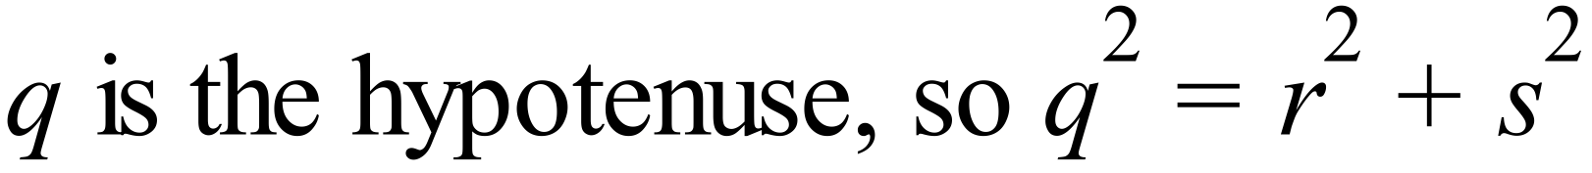 |  | 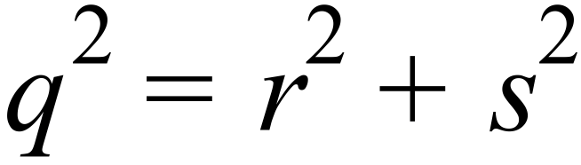
 | 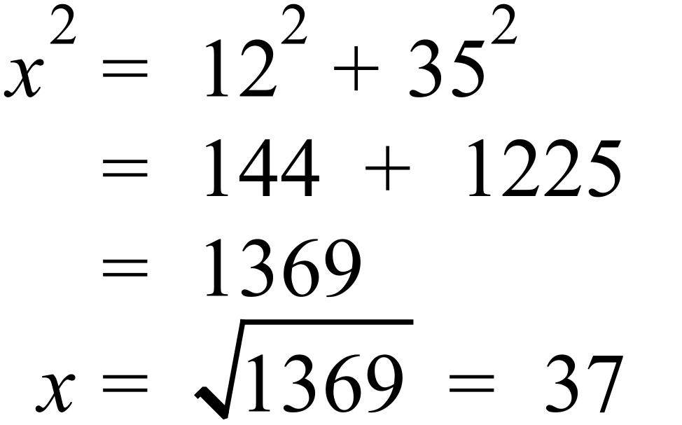 |  | 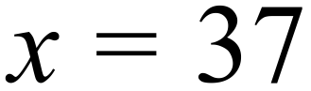
 | 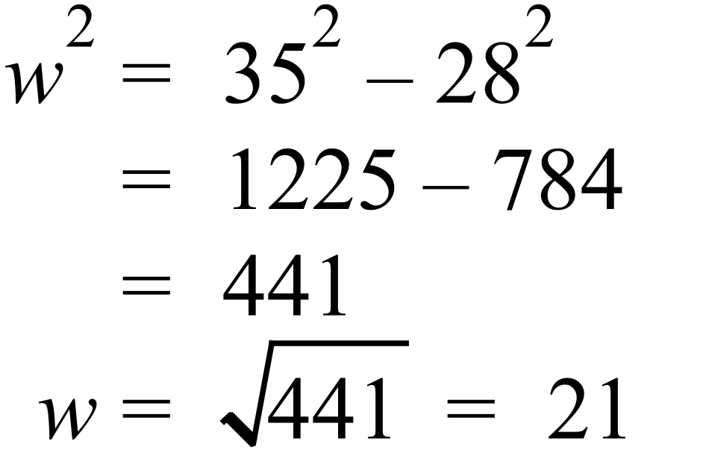 |  | 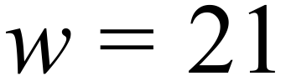
 | 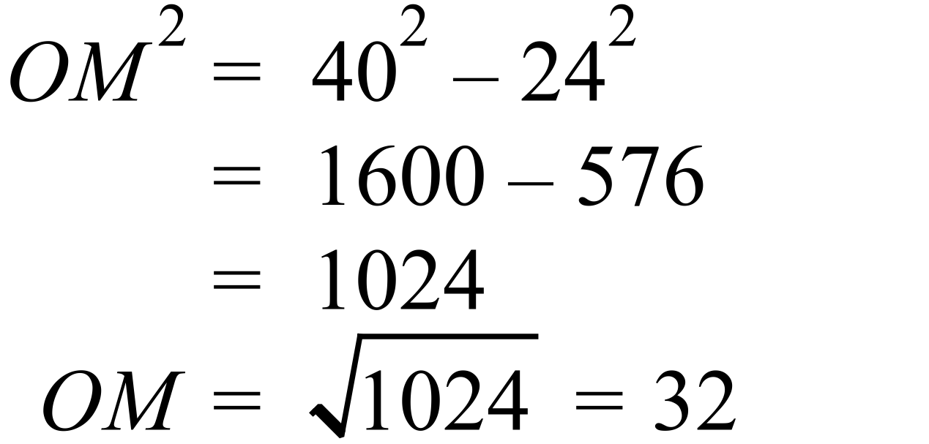 |  | 
 | 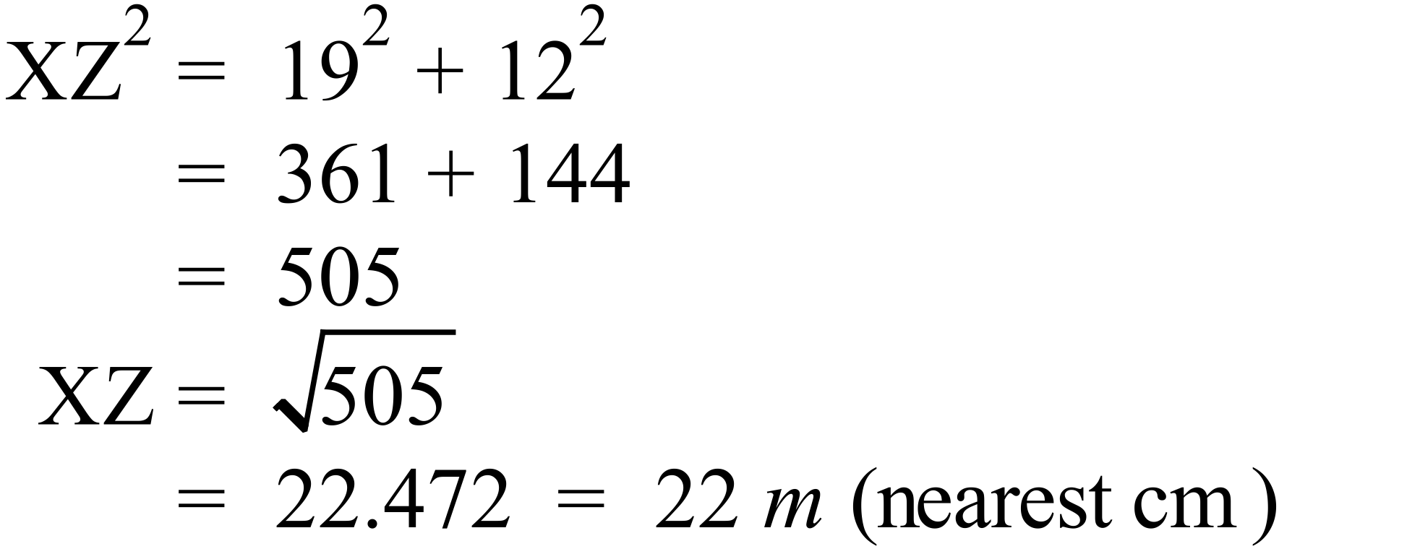
 | 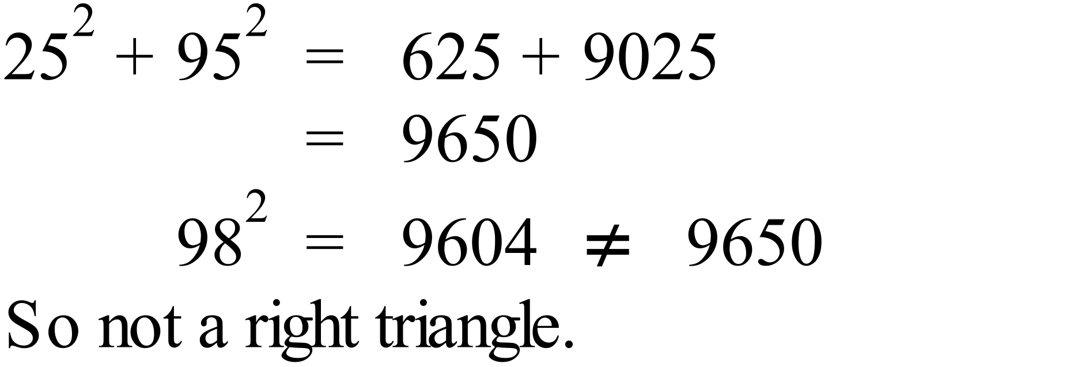 |  | Not right, see working (required)
 | 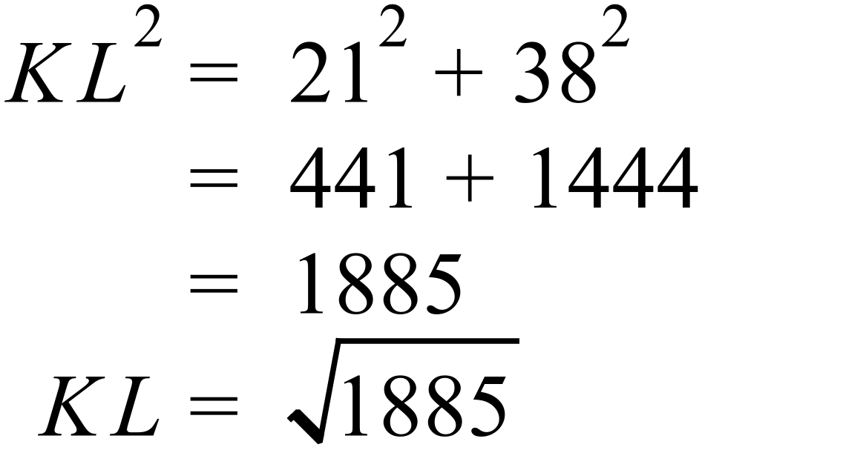 |  | 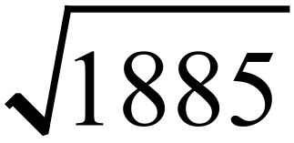
 | 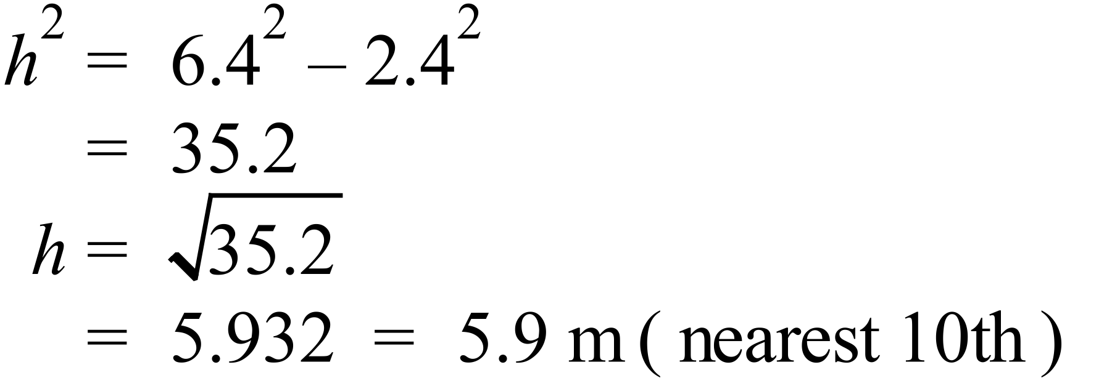 |  | 5.9 m
 | 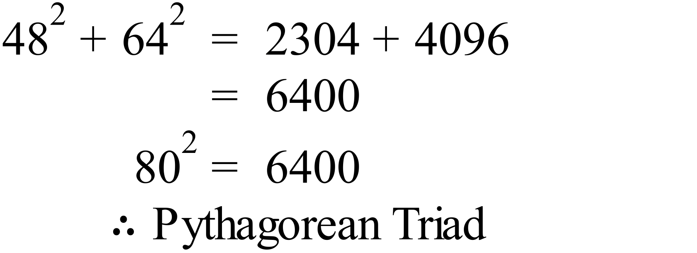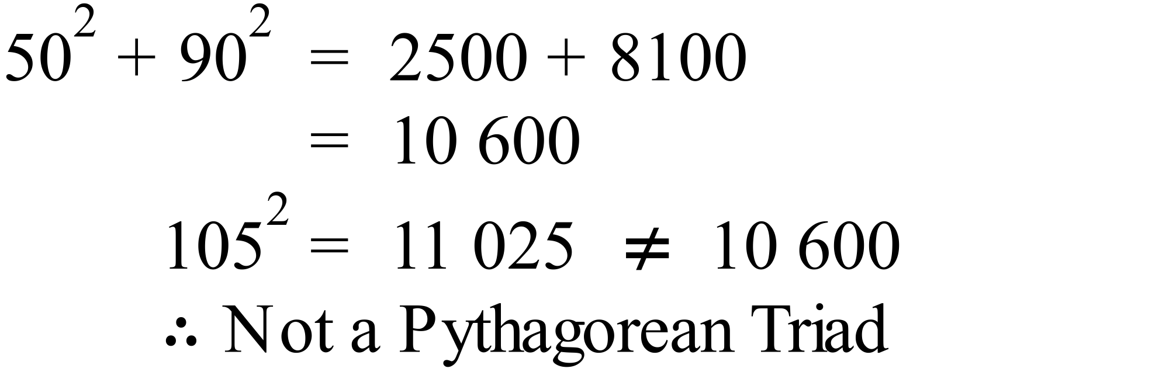 |  | Only Set A is a Pythagorean triad  See working which is required.
 | 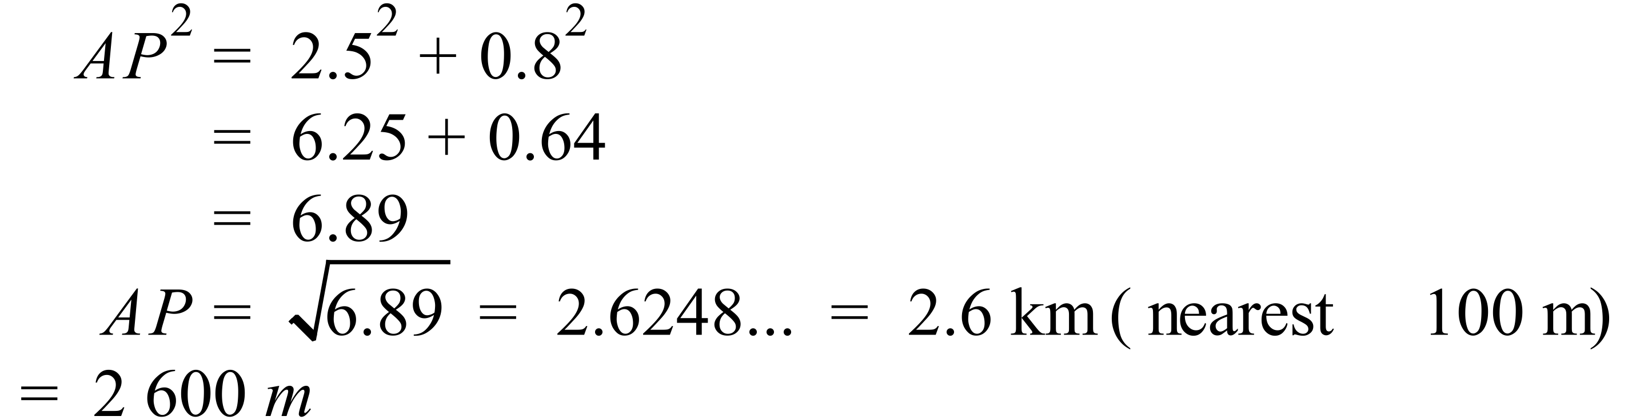 |  | 2 600 m
 | 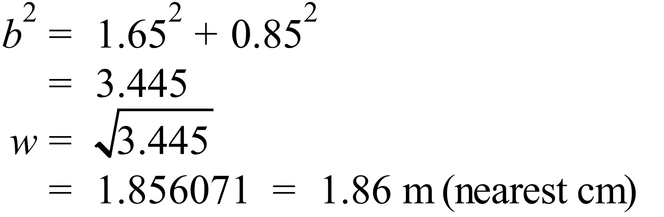 |  | 1.86 m
 | 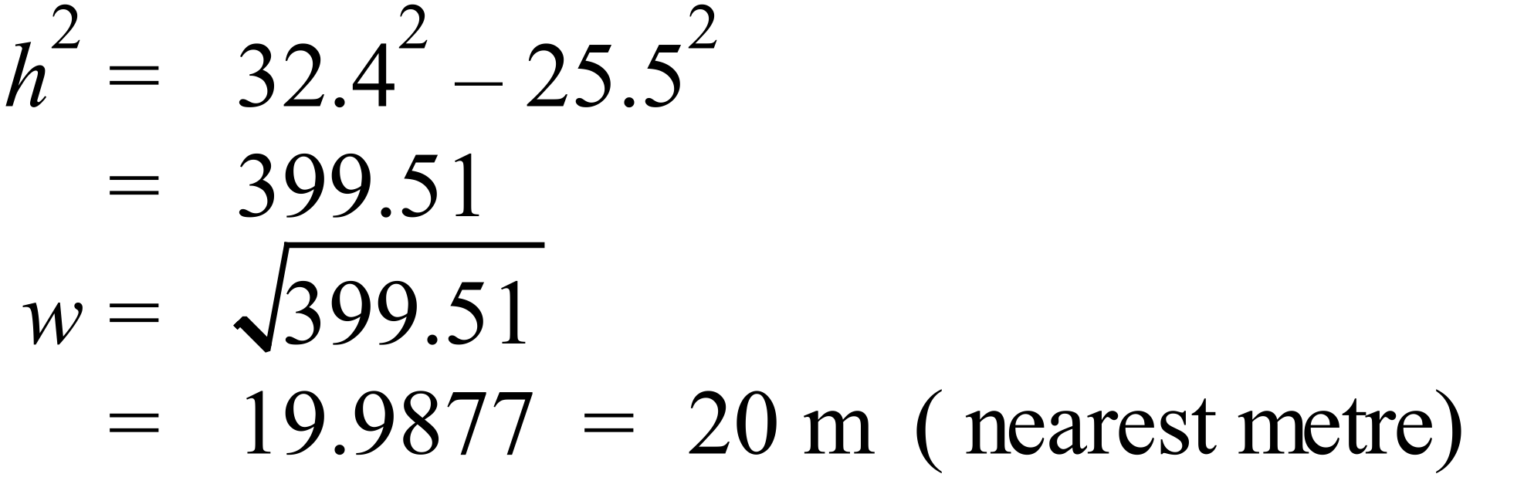 |  | 20 m
 | 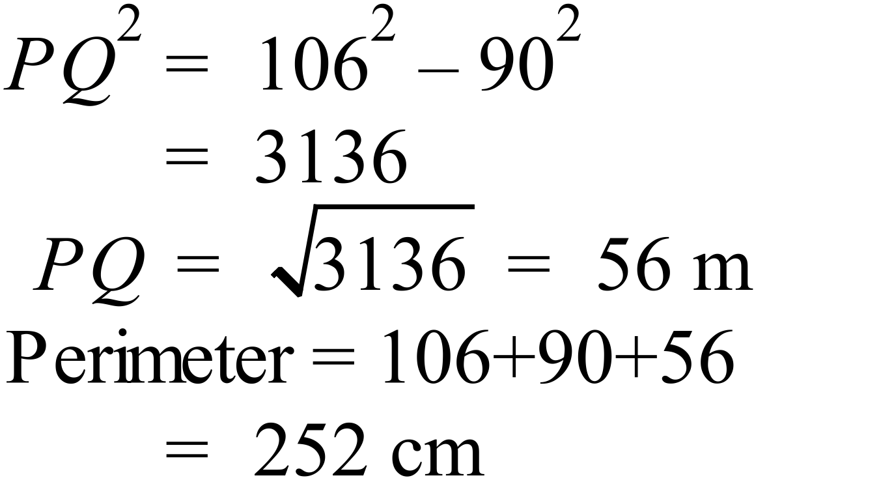 |  | 252 cm
 | 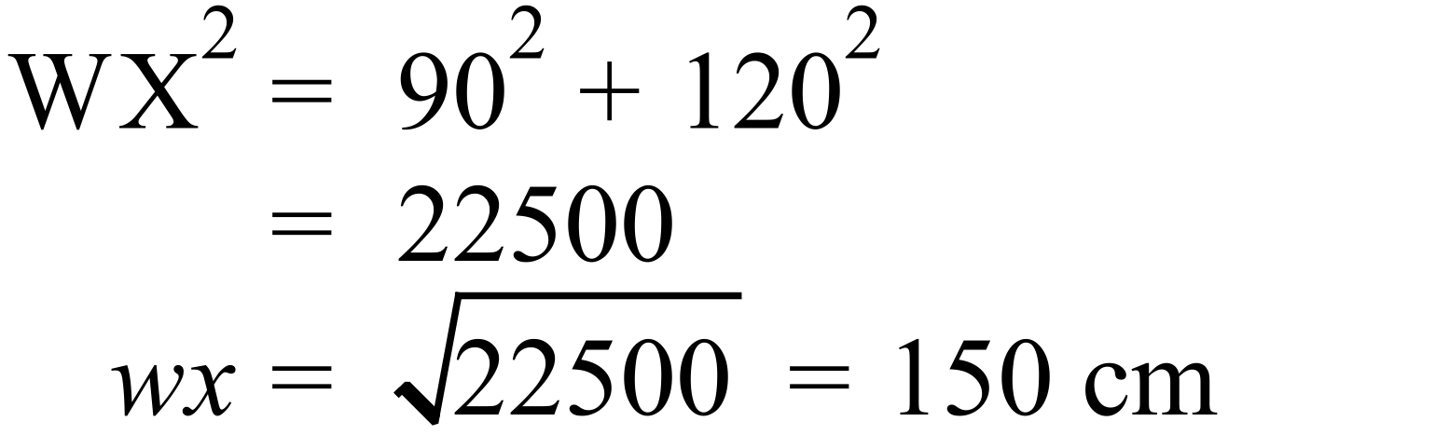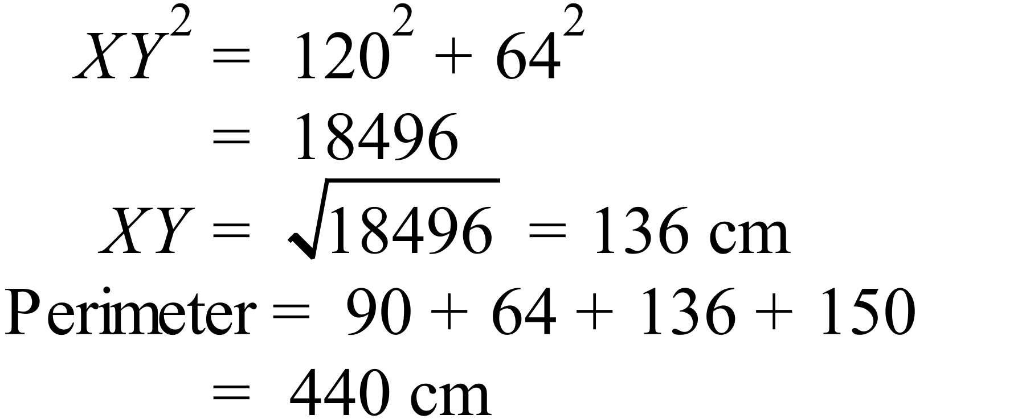 |  | 440 cm
 | 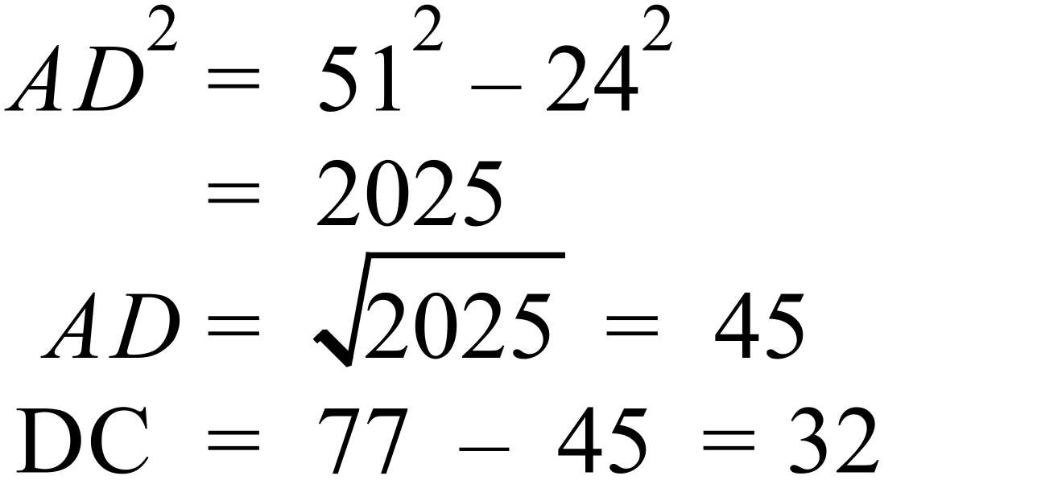  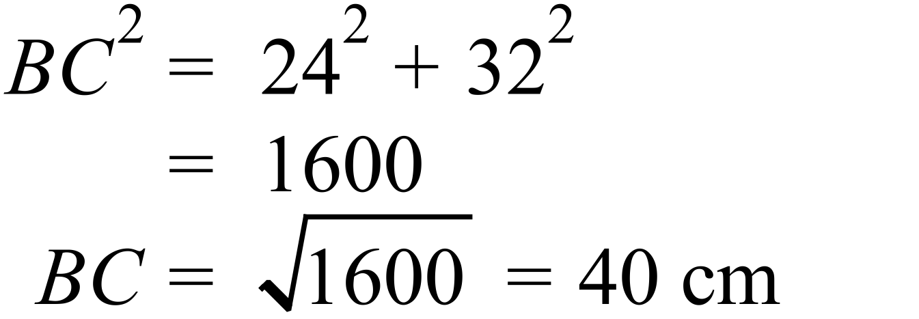 |  | 40 cm

Year 9 |  | Pythagoras Theorem | Calculator Allowed
Section 2 Multiple Choice Section
ANSWERS
No. | WORKING |  |  | ANSWER
 | TU is the longest and opposite to the right angle. |  |  | C
 | W is the hypotenuse so 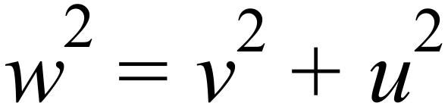 |  |  | D
 | 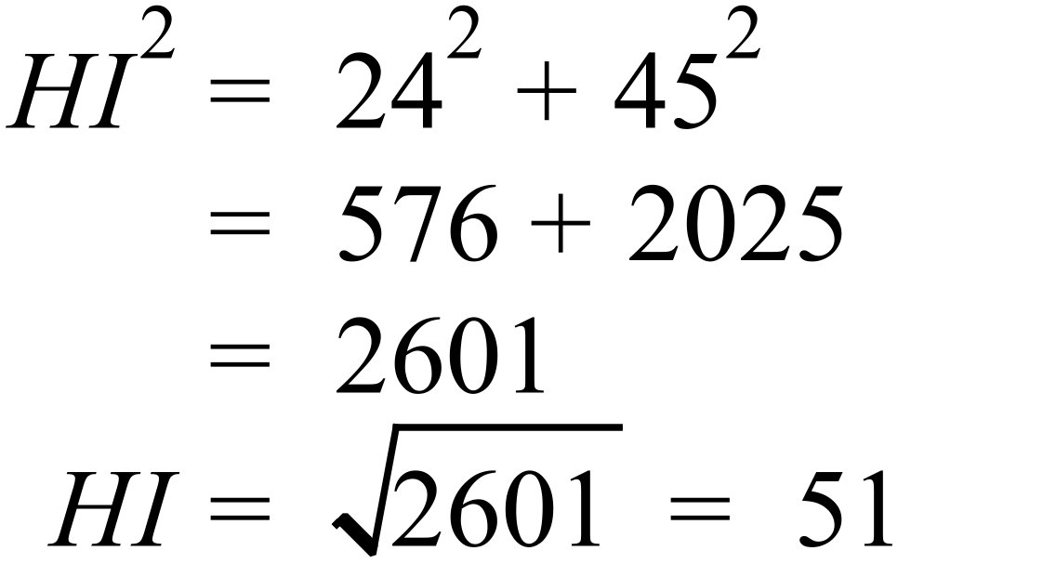 |  |  | C
 | 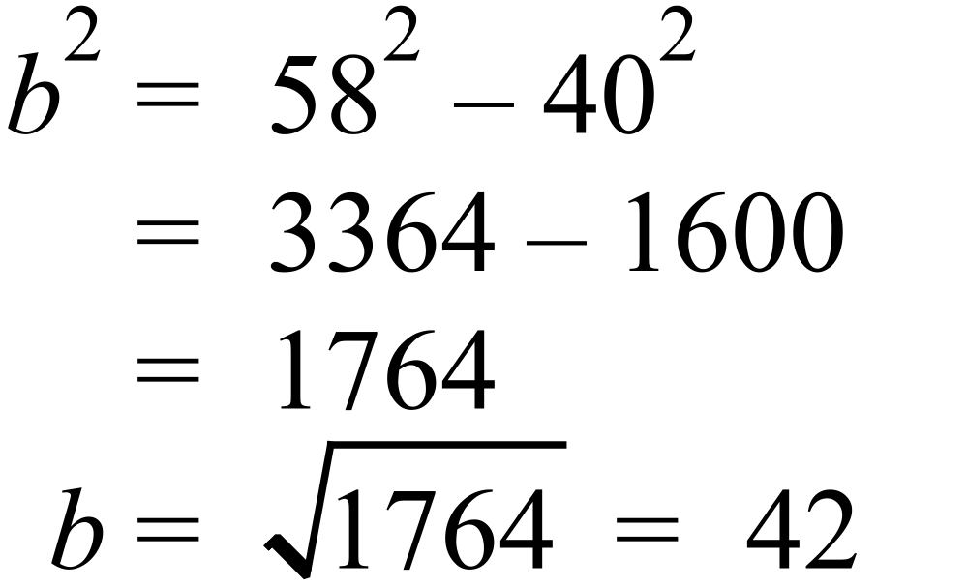 |  |  | B
 | 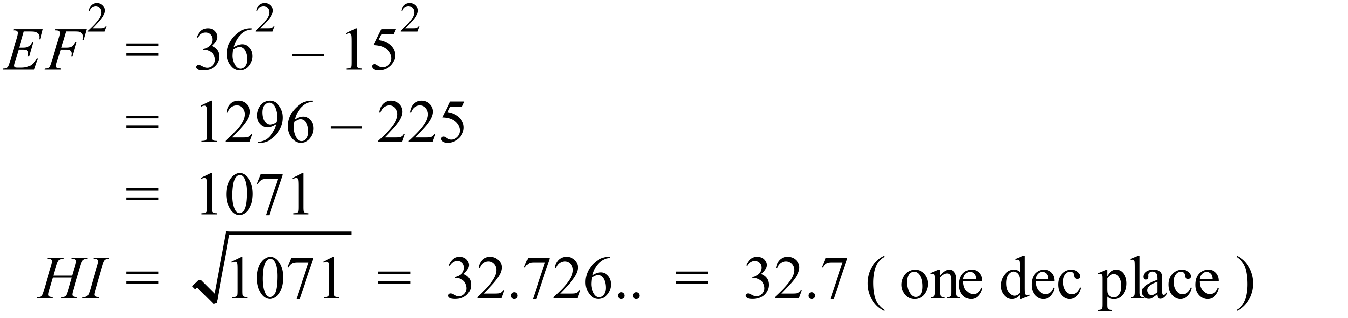 |  |  | B
 | 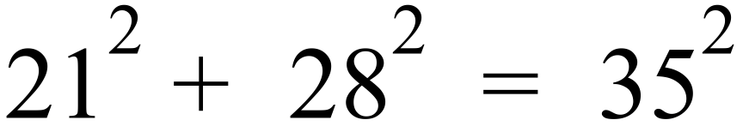 |  |  | D
 | 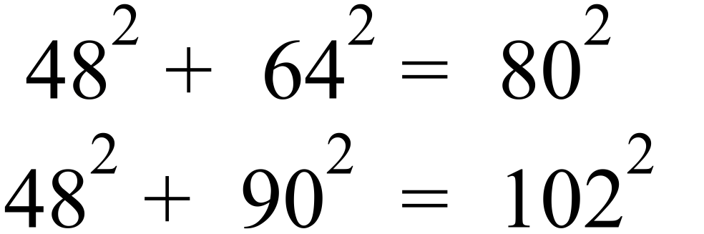  Both are right angled. |  |  | A
 | 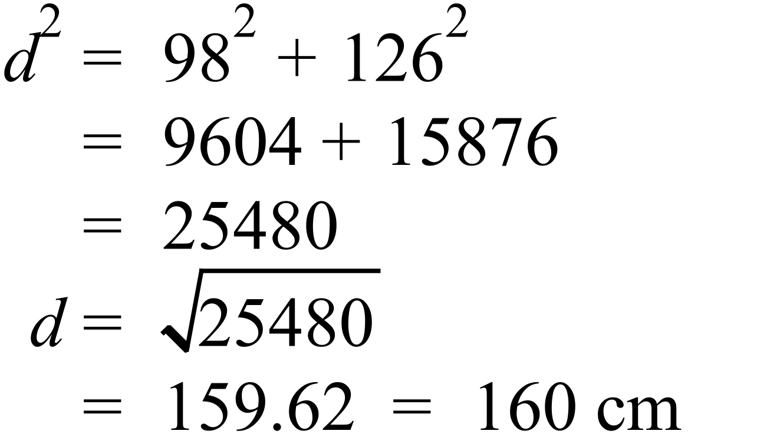 |  |  | A
 | 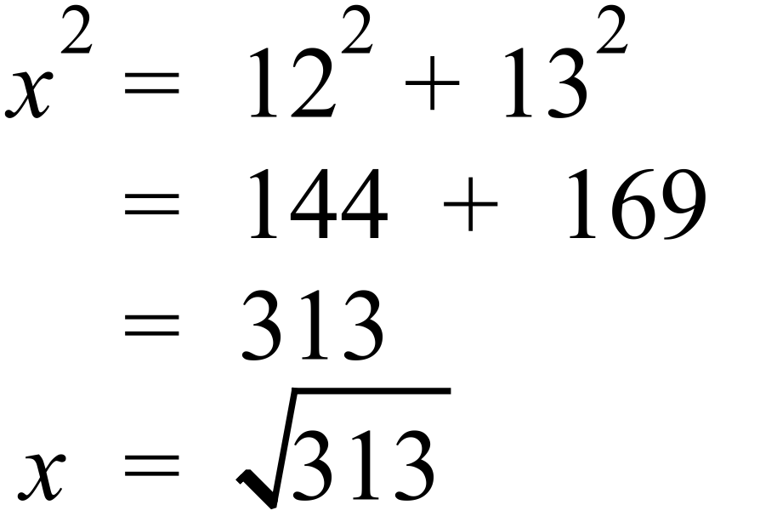 |  |  | C
 | 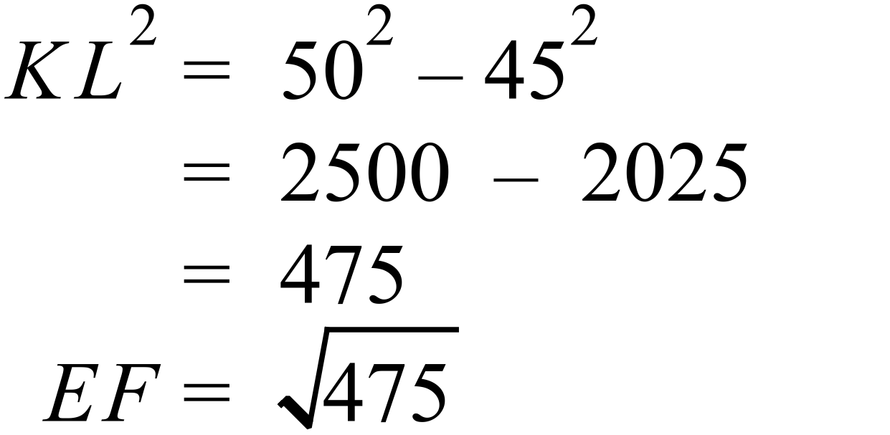 |  |  | B
 | 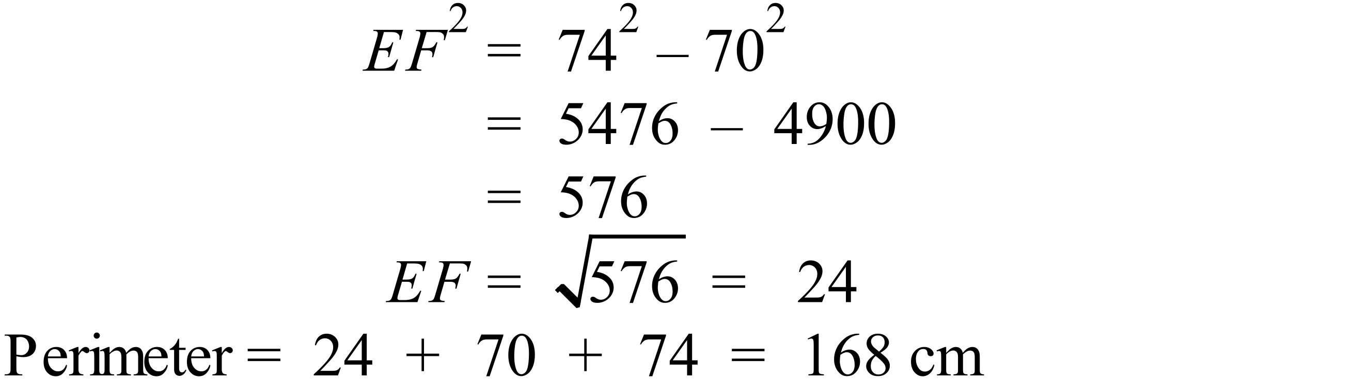 |  |  | C
 | 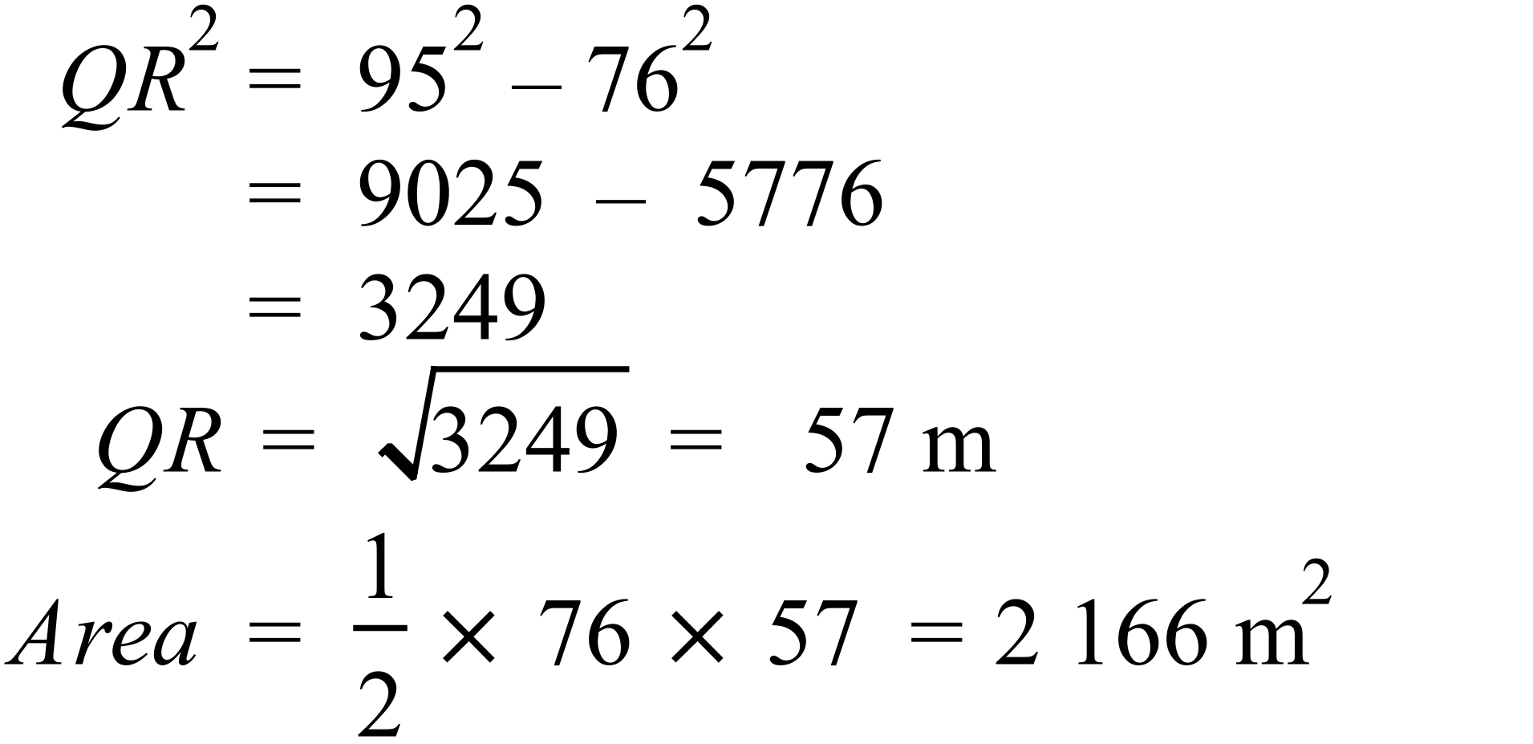 |  |  | C
 | 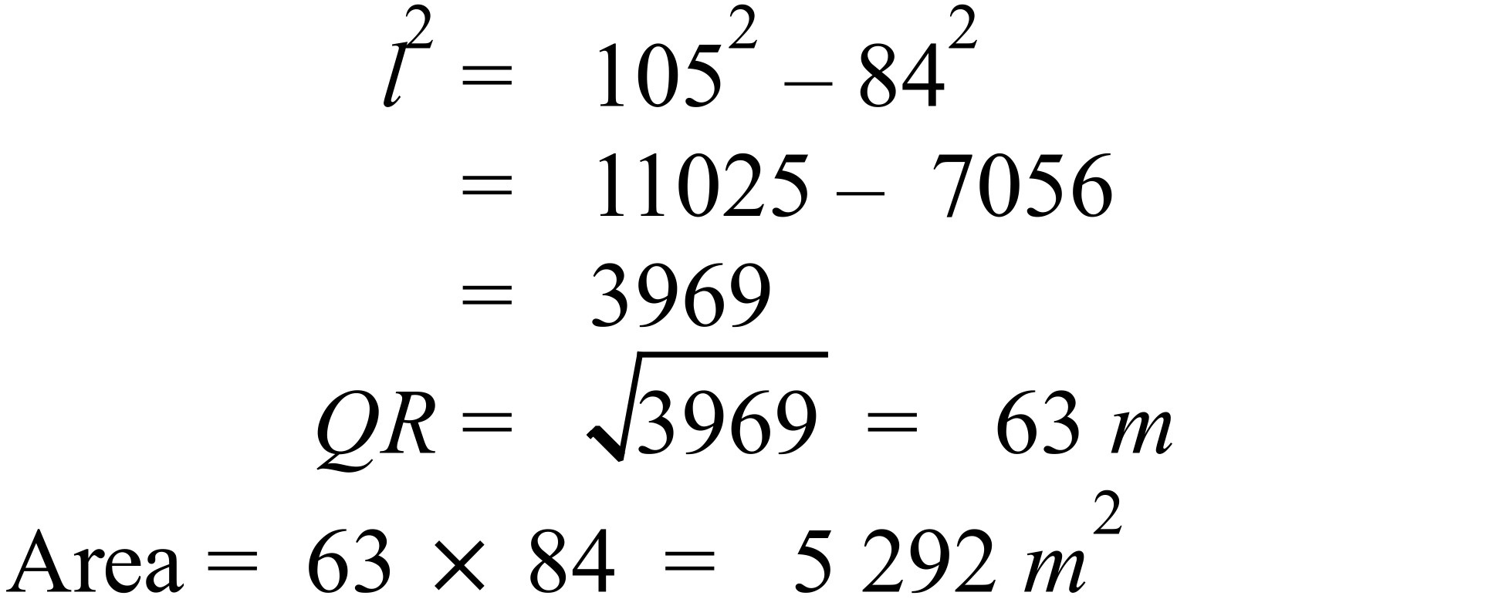 |  |  | A
 | 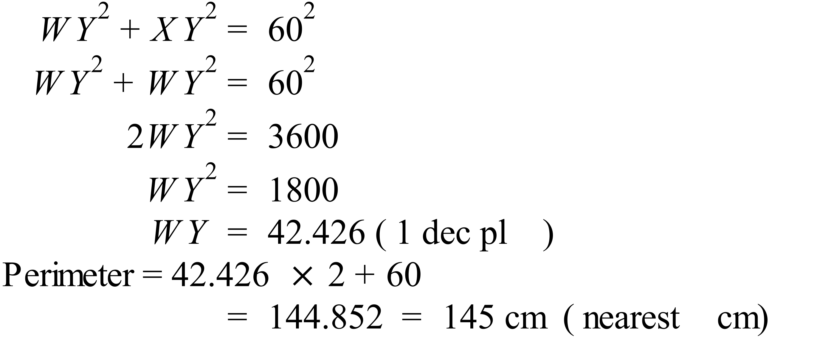 |  |  | B
 | 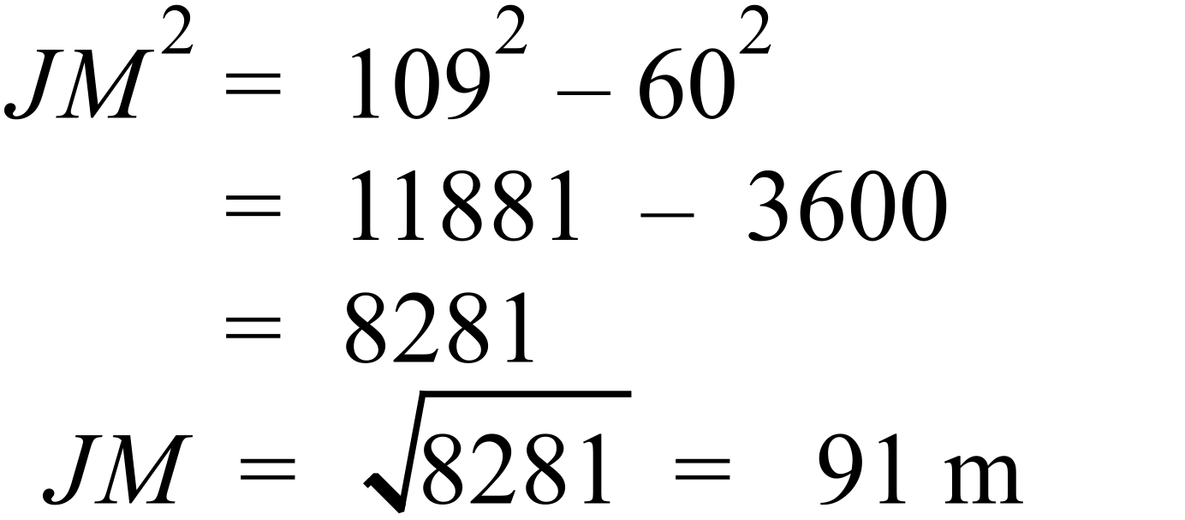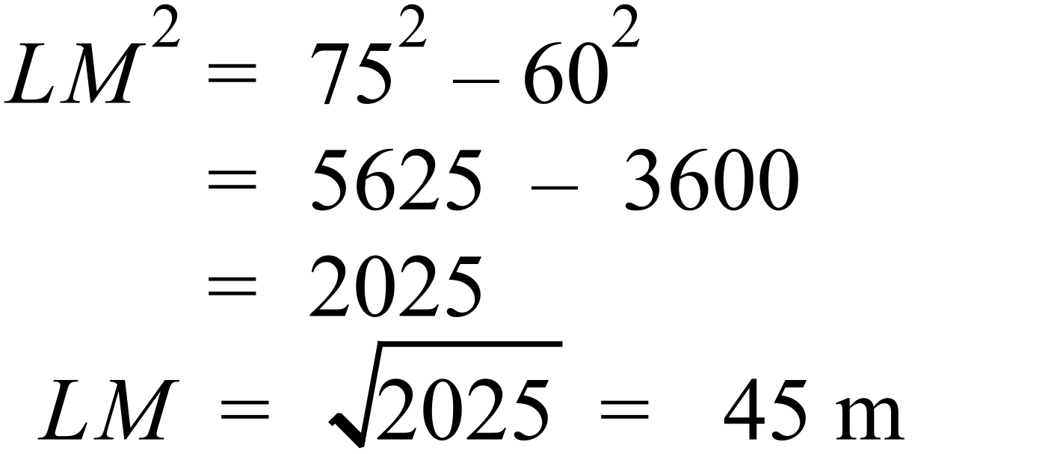 |  |  | D

Multiple Choice Answer Sheet
Pythagoras Theorem
Name _______ANSWERS_______________________________
Completely fill the response oval representing the most correct answer.

1. A B C D
2. A B C D
3. A B C D
4. A B C D
5. A B C D
6. A B C D
7. A B C D
8. A B C D
9. A B C D
10. A B C D
11. A B C D
12. A B C D
13. A B C D
14. A B C D
15. A B C D

